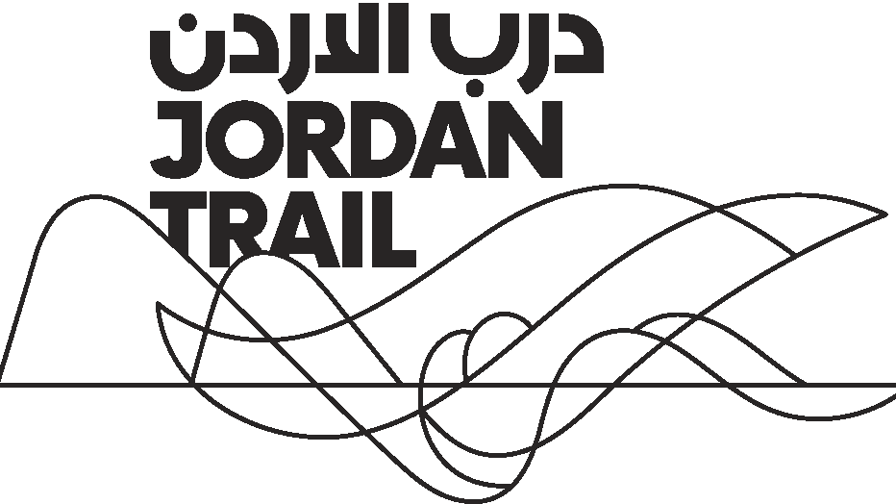

Jordan Trail Licensed Guides

No. | Name | Email Address | Mobile | Languages
1 | Abedlrahman Abu Dayah | abudayyehabood@gmail.com | 798596803 | Chinese
2 | Anas Ayasrah | Anas_ihsan@yahoo.com | 777505266 | English
3 | Ihab Alomari | white.stroke@yahoo.com | 799346297 | English
4 | Lama Hamdan | lama.hamdan@gmail.com | 777312291 | English
5 | Mahfouz Zayati | Zeta4tourism@hotmail.com | 795132083 | English
6 | Mahmoud Bdoul | mahmoud.bdoul@gmail.com | 772448166 | English
7 | Mohammad Al Zatimeh | elegance.lanad@yahoo.com | 790083137 | English
8 | Osama Awad | abunojod@hotmail.com | 790910056 | English
9 | Osama Rabya’ah | o.cori@hotmail.com | 795202102 | English
10 | Rafel Melhem | guiderafel@outlook.com | 796203326 | English
11 | Wa’el Majdalawieh | wael.mjd@gmail.com | 795258128 | English
12 | Wafa’a El Khatib | wafaa.khatib@hotmail.fr | 788575205 | English
13 | Yazan Al Abed | Yazanalabed8@gmail.com | 796282848 | English
14 | Zaher Omar Ayasrah | zaher222000@yahoo.com | 772325121 | English
15 | Abed al Rahim Mustafa | Abedelrahim.mustafa@gmail.com | 795551874 | English, French
16 | Abdallah A. As'ad | abdallah.asad1@gmail.com | 796038736 | English, French
17 | Ahmad Abu Ayyash | hamidoo60@hotmail.com | 795535078 | English, German
18 | Adnan Shatnawi | shatnawiadnan@yahoo.com | 795680708 | English, German
19 | Belal Amer | belalmr@yahoo.com | 795609055 | English, Russian
20 | Mays Abu Afifeh | maysmays9292@gmail.com | 790098102 | English, Russian
21 | Oscar Koshebye | oscar.koshebye@yahoo.es | 797020436 | English, Spanish
22 | Mohammad Malkawi | Mhdtareq.malkawi@gmail.com | 797510813 | French
23 | Mo’ad Youssef | moad.youssef@gmail.com | 796862327 | French
24 | Walid Al Marashdi | al.anaiber@yahoo.com | 772185425 | French
25 | Ahmad Al Jahlani | a.jahlany@ymail.com | 799604503 | German
26 | Ahmad Halaseh | Ahmad.halase@yahoo.com | 796455088 | German
27 | Fahid Qi’dan | fahed27@hotmail.com | 798415403 | German
28 | Fuad Al Hayek | Elhayek007@yahoo.de | 799342010 | German
29 | Mohammed Abu Nmeilih | mo_badawi1@yahoo.de | 795552138 | German
30 | Saleem Al Najeh | salim99@yahoo.com | 796790031 | German
31 | Ayyad Ayyad | ayyadayyad@me.com | 795529701 | German, English
32 | Saeed Asakreih | dababnehsaeed@gmail.com | 790137679 | Italian
33 | Dr. Eyas Abu Srour | eyas1974@gmail.com | 796830297 | Russian
34 | Ahmed Issa | ahmedjorguia@yahoo.com | 795485498 | Spanish

